[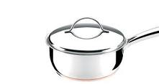](http://www.google.com/imgres?imgurl=http://www.rochedo.com.br/img/produtos/inox-cobre/panela_01.jpg&imgrefurl=http://www.rochedo.com.br/produtos/inox/%3Fproduto%3D338&usg=__sZGrW8PqWLvK9CUgmo34W1C0xXs=&h=270&w=509&sz=32&hl=en&start=0&zoom=1&tbnid=D7OI_q2V-w3Q1M:&tbnh=117&tbnw=221&ei=M_blTY-SI47ItAaRr9GjCA&prev=/search%3Fq%3DPANELA%26um%3D1%26hl%3Den%26biw%3D1260%26bih%3D816%26tbm%3Disch&um=1&itbs=1&iact=rc&dur=218&page=1&ndsp=21&ved=1t:429,r:7,s:0&tx=171&ty=80)[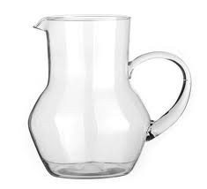](http://www.google.com/imgres?imgurl=http://www.psdovidro.com.br/images/produtos/Jarra_Patricia_M%C3%A9dia_04131-22.jpg&imgrefurl=http://www.psdovidro.com.br/detalhes_produto.asp%3Fid%3D581&usg=__fi8cq2e6eEK6RZQHMqmzuWwqfAw=&h=400&w=440&sz=13&hl=en&start=0&zoom=1&tbnid=9Drw7YnYeXj1dM:&tbnh=166&tbnw=200&ei=y_blTYyAI4vUsgaOyMmcCA&prev=/search%3Fq%3Djarra%26um%3D1%26hl%3Den%26biw%3D1260%26bih%3D816%26tbm%3Disch&um=1&itbs=1&iact=rc&dur=0&page=1&ndsp=24&ved=1t:429,r:5,s:0&tx=123&ty=82)[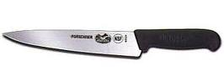](http://www.google.com/imgres?imgurl=http://4.bp.blogspot.com/_ZBF1Y2J8yYg/TS4oTGWntKI/AAAAAAAAEVc/2LKOcmD2Oak/s1600/talher-faca.jpg&imgrefurl=http://ola-comoestas.blogspot.com/2011/01/talheres-oficinas-e-escritorios.html&usg=__wseZQHXL19aY5B7u3qBOeBmmCRQ=&h=154&w=420&sz=8&hl=en&start=0&zoom=1&tbnid=aOIOmRcjTIc83M:&tbnh=81&tbnw=222&ei=yPTlTaaHBMHUtAb11KWECA&prev=/search%3Fq%3DTALHERES%2BFACA%26um%3D1%26hl%3Den%26biw%3D1260%26bih%3D816%26tbm%3Disch&um=1&itbs=1&iact=rc&dur=31&page=1&ndsp=24&ved=1t:429,r:14,s:0&tx=63&ty=56)[](http://www.google.com/imgres?imgurl=http://www.lzcozinha.com.br/upload/imagem_ecommerce_produto_generico/1809/31911.jpg&imgrefurl=http://www.lzcozinha.com.br/website/ecommerce_produto.asp%3Fcod%3D1809%26idi%3D1%26id_categoria_generico%3D4146&usg=__UspzKSYWNM3D3Gf3EJkHMJvBK6o=&h=280&w=280&sz=14&hl=en&start=0&zoom=1&tbnid=WiC3t9WwhdK89M:&tbnh=155&tbnw=155&ei=9fTlTcCpFIX5sgaJl_CRCA&prev=/search%3Fq%3DTALHERES%2BGARFO%26um%3D1%26hl%3Den%26biw%3D1260%26bih%3D816%26tbm%3Disch&um=1&itbs=1&iact=rc&dur=78&page=1&ndsp=24&ved=1t:429,r:1,s:0&tx=70&ty=86)[](http://www.google.com/imgres?imgurl=http://www.lzcozinha.com.br/upload/imagem_ecommerce_produto_generico/1809/23316.jpg&imgrefurl=http://www.lzcozinha.com.br/website/ecommerce_produto.asp%3Fcod%3D1809%26idi%3D1%26id_categoria_generico%3D4146&usg=__KLgRWm0Xe6vUiBYqEYCQbjQw0y0=&h=280&w=280&sz=13&hl=en&start=170&zoom=1&tbnid=VJ0Tuh4s5Tu9MM:&tbnh=154&tbnw=154&ei=KvXlTZTMIY-SswaA_IigCA&prev=/search%3Fq%3DTALHERES%2BCOLHER%26um%3D1%26hl%3Den%26biw%3D1260%26bih%3D816%26tbm%3Disch&um=1&itbs=1&iact=rc&dur=0&page=8&ndsp=24&ved=1t:429,r:19,s:170&tx=108&ty=61)[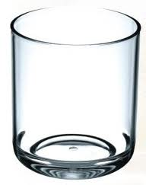](http://www.google.com/imgres?imgurl=http://www.euroferragens.com.br/figurasLoja/Kos-CopoWhisky.jpg&imgrefurl=http://www.euroferragens.com.br/loja.phtml%3Ff%3D1%26cprod%3D1422&usg=__1eOEjavbnXtmjkPoJaA0Gh8x8H4=&h=304&w=241&sz=13&hl=en&start=0&zoom=1&tbnid=DUSgzW2GeXG4fM:&tbnh=175&tbnw=139&ei=F_blTamiG8zSsgaA1YCcCA&prev=/search%3Fq%3DCOPO%26um%3D1%26hl%3Den%26biw%3D1260%26bih%3D816%26tbm%3Disch&um=1&itbs=1&iact=rc&dur=219&page=1&ndsp=24&ved=1t:429,r:10,s:0&tx=97&ty=71)[](http://www.google.com/imgres?imgurl=http://4.bp.blogspot.com/-pNh_kgOihQo/TcnKgCizybI/AAAAAAAAAHk/-dE8d7is48M/s1600/Taca-cristal.gif&imgrefurl=http://norberto-garin.blogspot.com/2011/05/taca-de-cristal.html&usg=__1HvDH4rsKUu3l2IDJJS-hIm0QYI=&h=290&w=290&sz=12&hl=en&start=0&zoom=1&tbnid=TjPAwmr0h59imM:&tbnh=148&tbnw=149&ei=OPflTdy2NpDRsgbDjPmRCA&prev=/search%3Fq%3Dtaca%26um%3D1%26hl%3Den%26biw%3D1260%26bih%3D816%26tbm%3Disch&um=1&itbs=1&iact=rc&dur=15&page=1&ndsp=21&ved=1t:429,r:20,s:0&tx=92&ty=63)[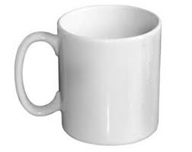](http://www.google.com/imgres?imgurl=http://www.fixarts.com.br/image_minica_caneca_americana.jpg&imgrefurl=http://www.fixarts.com.br/pag_mini_canecas.htm&usg=__iluvMl6oY3MfpIyXDg2qUuvaLw8=&h=278&w=350&sz=6&hl=en&start=0&zoom=1&tbnid=DhFWEB99C-NNnM:&tbnh=160&tbnw=188&ei=4PblTZmzIYqGswbE_rCUCA&prev=/search%3Fq%3Dcaneca%26um%3D1%26hl%3Den%26biw%3D1260%26bih%3D816%26tbm%3Disch&um=1&itbs=1&iact=rc&dur=282&page=1&ndsp=24&ved=1t:429,r:20,s:0&tx=115&ty=69)[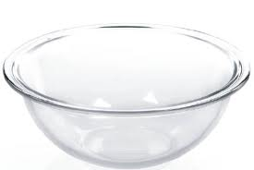](http://www.google.com/imgres?imgurl=http://www.peixoto.com.br/catalogo/imagens/140422.jpg&imgrefurl=http://www.peixoto.com.br/catalogo/index.php%3Ftype%3Dbusca%26cat%3D83%26dep%3D9%26sec%3D49%26val%3D0&usg=__GfX_5YIO3zbwdDaygo8zE_ARkJs=&h=285&w=426&sz=10&hl=en&start=0&zoom=1&tbnid=sPtuCZNWZpoqPM:&tbnh=140&tbnw=209&ei=yPflTc6QCMfPsgbTuryQCA&prev=/search%3Fq%3Dtigela%26um%3D1%26hl%3Den%26biw%3D1260%26bih%3D816%26tbm%3Disch&um=1&itbs=1&iact=rc&dur=31&page=1&ndsp=22&ved=1t:429,r:12,s:0&tx=180&ty=55)[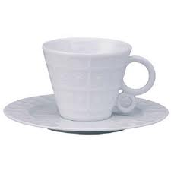](http://www.google.com/imgres?imgurl=http://www.maghomestyle.com.br/octopus/design/images/75/products/b/Xicara-Para-cafe-008777.jpg&imgrefurl=http://www.maghomestyle.com.br/xicara-para-cafe-em-porcelana---limoges-osmose-110-ml/008777/75/1806&usg=__VZN-m7bLNBVY89ekuILn-ttxrOE=&h=350&w=350&sz=8&hl=en&start=117&zoom=1&tbnid=LvOjCqJ1MVcf2M:&tbnh=155&tbnw=180&ei=fPblTdfqEMHdtAb_uZyNCA&prev=/search%3Fq%3Dx%25C3%25ADcara%26um%3D1%26hl%3Den%26biw%3D1260%26bih%3D816%26tbm%3Disch&um=1&itbs=1&iact=rc&dur=390&page=6&ndsp=23&ved=1t:429,r:18,s:117&tx=108&ty=96)[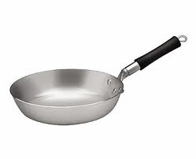](http://www.google.com/imgres?imgurl=http://www.regitronic.com.br/config/imagens_conteudo/produtos/imagensGRD/GRD_1738_frigideira.jpg&imgrefurl=http://www.regitronic.com.br/venda/1738/Frigideira-Aluminio-com-Cabo-Baquelite-N-30.html&usg=__OAOhDijCvzeCU58_oLo3dxiufTw=&h=284&w=350&sz=7&hl=en&start=0&zoom=1&tbnid=jIw74_56oNrozM:&tbnh=146&tbnw=180&ei=YPblTd2gDoPVtAbP_sCECA&prev=/search%3Fq%3Dfrigideira%26um%3D1%26hl%3Den%26biw%3D1260%26bih%3D816%26tbm%3Disch&um=1&itbs=1&iact=rc&dur=0&page=1&ndsp=24&ved=1t:429,r:23,s:0&tx=57&ty=48)[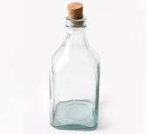](http://www.google.com/imgres?imgurl=http://www.psdovidro.com.br/images/produtos/Garrafa__04099-81.jpg&imgrefurl=http://www.psdovidro.com.br/detalhes_produto.asp%3Fid%3D74&usg=__Y9EVeVjhXqWxHxf4SAV1eC5LRRs=&h=400&w=440&sz=35&hl=en&start=0&zoom=1&tbnid=zHC8YepneXziCM:&tbnh=149&tbnw=151&ei=R_flTcDnNcWztAah-ryZCA&prev=/search%3Fq%3Dgarrafa%26um%3D1%26hl%3Den%26biw%3D1260%26bih%3D816%26tbm%3Disch&um=1&itbs=1&iact=rc&dur=0&page=1&ndsp=24&ved=1t:429,r:10,s:0&tx=116&ty=81)[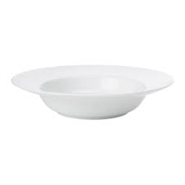](http://www.google.com/imgres?imgurl=http://www.ikea.com/fi/fi/images/products/ikea--syva-lautanen-valkoinen__72570_PE188485_S4.jpg&imgrefurl=http://www.ikea.com/fi/fi/catalog/products/20116170&usg=__sqsYNNvkt2wLRczUmaydzc94ldk=&h=500&w=500&sz=5&hl=en&start=0&zoom=1&tbnid=uIo5k5k4AhEbMM:&tbnh=156&tbnw=184&ei=6_XlTYH6E8LftAbG4e2ACA&prev=/search%3Fq%3DLAUTANEN%26um%3D1%26hl%3Den%26biw%3D1260%26bih%3D816%26tbm%3Disch&um=1&itbs=1&iact=rc&dur=109&page=1&ndsp=22&ved=1t:429,r:9,s:0&tx=94&ty=64)

PIRES

FRIGIDEIRA

GARRAFA

TAÇA

COPO

TAMPA

PANELA

CANECA

TIGELA

XÍCARA

JARRA

PRATO

FACA

GARFO

COLHER