<http://www.youtube.com/watch?v=6R-oPyIIcwY&feature=related>

[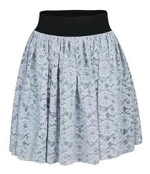](http://www.google.com/imgres?imgurl=http://4.bp.blogspot.com/_CLX3N0I4QGU/TQF1bnGJCrI/AAAAAAAACzw/2R37OVaEBcs/s1600/saia+de+renda.bmp&imgrefurl=http://baton-cris.blogspot.com/2010/12/wish-list-de-verao.html&usg=__tPBLTQR7YpLwSw0pbCvqrc0VN8I=&h=695&w=600&sz=97&hl=en&start=25&zoom=1&tbnid=4JN4-3mDLmnOgM:&tbnh=154&tbnw=129&ei=-931TfjkE4TZtAa8mbWsBg&prev=/search?q=saia+de+renda&um=1&hl=en&biw=1260&bih=816&tbm=isch&um=1&itbs=1&iact=rc&dur=31&page=2&ndsp=26&ved=1t:429,r:1,s:25&tx=83&ty=43)[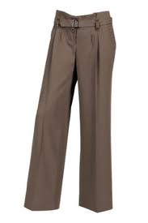](http://www.google.com/imgres?imgurl=http://www.modaparausar.com/wp-content/uploads/2008/11/riccicolella_004.jpg&imgrefurl=http://www.modaparausar.com/2008/11/alguns-itens-que-nao-podem-faltar-em-seu-armario/&usg=__z6vDgZkH4dvv1051L07JjJZSKIs=&h=400&w=266&sz=9&hl=en&start=0&zoom=1&tbnid=zRBtlRgXbg7XnM:&tbnh=184&tbnw=119&ei=8tv1Te6cGsKCswbOntm_Bg&prev=/search?q=calca+social&um=1&hl=en&biw=1260&bih=816&tbm=isch&um=1&itbs=1&iact=rc&dur=0&page=1&ndsp=29&ved=1t:429,r:26,s:0&tx=112&ty=47)[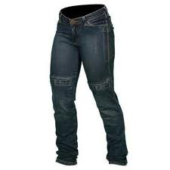](http://www.google.com/imgres?imgurl=https://www.sbsmotos.com.br/media/catalog/product/cache/1/image/5e06319eda06f020e43594a9c230972d/f/i/file_6_3.jpg&imgrefurl=https://www.sbsmotos.com.br/casual-sport/calca-jeans-spirit-feminina-com-protec-o.html&usg=__uPSiXx0at-ircI49LAwzu88I45w=&h=350&w=350&sz=10&hl=en&start=131&zoom=1&tbnid=TpcAxEur3yzb1M:&tbnh=151&tbnw=151&ei=i9z1TaPSDMrKtAbF0dCnBg&prev=/search?q=calca+jeans+feminina&um=1&hl=en&biw=1260&bih=816&tbm=isch&um=1&itbs=1&iact=rc&dur=109&page=6&ndsp=29&ved=1t:429,r:21,s:131&tx=60&ty=93)[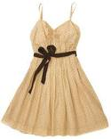](http://www.google.com/imgres?imgurl=http://territoriofeminino.blogtv.uol.com.br/img/Image/MulheresPossveis/2008/Julho/vestido-de-bolinha.jpg&imgrefurl=http://www.omegageek.com.br/forum/showthread.php?t=5804&page=2&usg=__aGYo-3LxdxKQpDJcswuLNDzdjkU=&h=500&w=400&sz=35&hl=en&start=0&zoom=1&tbnid=yjd3VOYe7fq3hM:&tbnh=150&tbnw=120&ei=JNv1TdntFYjetAb004SnBg&prev=/search?q=vestido+de+alcinha&um=1&hl=en&biw=1260&bih=816&tbm=isch&um=1&itbs=1&iact=rc&dur=32&page=1&ndsp=30&ved=1t:429,r:12,s:0&tx=72&ty=132)

**VESTIDO**

**JEANS**

**SAIA**

**CALÇA**

[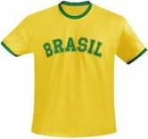](http://www.google.com/imgres?imgurl=http://images.bymk.com.br/Items/Item-73217-500.jpg&imgrefurl=http://www.bymk.com.br/itens/73217/camiseta-torcida-do-brasil&usg=__R46LwXUzVI_2LM4SLwHHCkz917g=&h=272&w=290&sz=8&hl=en&start=0&zoom=1&tbnid=itRsORGuDGf6JM:&tbnh=156&tbnw=166&ei=eeP1Teq2CsaytAauqpy0Bg&prev=/search?q=camiseta+brasil&um=1&hl=en&biw=1260&bih=816&tbm=isch&um=1&itbs=1&iact=rc&dur=0&page=1&ndsp=27&ved=1t:429,r:5,s:0&tx=113&ty=68)[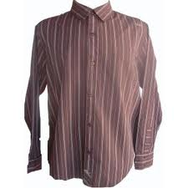](http://www.google.com/imgres?imgurl=http://user.img.todaoferta.uol.com.br/A/0/YA/JVNO2U/1224507438563_bigPhoto_0.jpg&imgrefurl=http://todaoferta.uol.com.br/comprar/camisa-tony-hawk-social-masculina-original-importada-A0YAJVNO2U&usg=__cpcKCfjm5Jb2vUDFO-HbqfeORwU=&h=300&w=300&sz=13&hl=en&start=0&zoom=1&tbnid=g6xONQXJ3mEXMM:&tbnh=156&tbnw=156&ei=AuT1TaylOMnDswaNyZmZBg&prev=/search?q=camisa+masculina&um=1&hl=en&biw=1260&bih=816&tbm=isch&um=1&itbs=1&iact=rc&dur=0&page=1&ndsp=25&ved=1t:429,r:7,s:0&tx=103&ty=63)[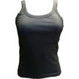](http://www.google.com/imgres?imgurl=http://www.rosadosventosrio.com.br/media/catalog/product/cache/1/small_image/135x135/9df78eab33525d08d6e5fb8d27136e95/f/i/file_2_80.jpg&imgrefurl=http://www.rosadosventosrio.com.br/femininas.html&usg=__USbpRItnOLZpfNaGjUk-2GSetyw=&h=135&w=135&sz=4&hl=en&start=215&zoom=1&tbnid=CH350iac_1MpYM:&tbnh=108&tbnw=108&ei=tuD1TbSAHcWztAb1m42tBg&prev=/search?q=regatinha&um=1&hl=en&biw=1260&bih=816&tbm=isch&um=1&itbs=1&iact=rc&dur=16&page=9&ndsp=28&ved=1t:429,r:18,s:215&tx=74&ty=86)[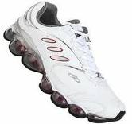](http://www.google.com/imgres?imgurl=http://www.strobous.com/wp-content/uploads/2010/05/t%C3%AAnis-zomax-olimpicus.jpg&imgrefurl=http://www.strobous.com/tenis-zomax-olympikus.html&usg=__3AR0po9iOiIoOYmiZL-JwVC3z1Y=&h=328&w=350&sz=9&hl=en&start=41&zoom=1&tbnid=I13hn05_aFTl6M:&tbnh=112&tbnw=120&ei=d-b1TabODMTF8QOmnt2oBw&prev=/search?q=t%C3%AAnis&um=1&hl=en&biw=1260&bih=816&tbm=isch&um=1&itbs=1)

**TÊNIS**

**REGATA**

**CAMISA**

**CAMISETA**

[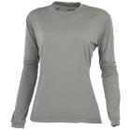](http://www.google.com/imgres?imgurl=http://www.motostore.com.br/images/product/23005P_1500.JPG&imgrefurl=http://www.motostore.com.br/camisetasoloionlitemangalongafemininacinza,product,23005PP,1356.aspx&usg=__E4TYD7pK6bQZbfoHdjj0VvevzKk=&h=1500&w=1500&sz=222&hl=en&start=27&zoom=1&tbnid=9R7jN1kHh7rJlM:&tbnh=138&tbnw=138&ei=d-L1TeP7MdGDswb2pcygBg&prev=/search?q=blusa+feminina+de+manga+longa&um=1&hl=en&biw=1260&bih=816&tbm=isch&um=1&itbs=1&iact=rc&dur=234&page=2&ndsp=27&ved=1t:429,r:3,s:27&tx=83&ty=93)[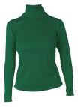](http://www.google.com/imgres?imgurl=http://img.ph2-jpg.posthaus.com.br/Web/posthaus/foto/moda-feminina/blusas-manga-longa/blusa-feminina-manga-longa-verde_59118_130_1.jpg&imgrefurl=http://www.posthaus.com.br/blusas-manga-longa/modafeminina?img=blusas-manga-longa&acao=produtos&cat=1&sub=1&sn=13&usg=__l715UJNNzNZVkcLoxVF2uSkm4f4=&h=179&w=130&sz=5&hl=en&start=0&zoom=1&tbnid=gYKpDjmqCisaDM:&tbnh=143&tbnw=104&ei=d-L1TeP7MdGDswb2pcygBg&prev=/search?q=blusa+feminina+de+manga+longa&um=1&hl=en&biw=1260&bih=816&tbm=isch&um=1&itbs=1&iact=rc&dur=0&page=1&ndsp=27&ved=1t:429,r:16,s:0&tx=24&ty=69)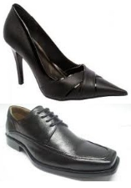[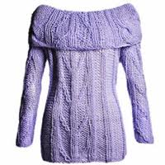](http://www.google.com/imgres?imgurl=http://www.brinquedodemulher.net/wp-content/uploads/2011/04/blusa_trico.jpg&imgrefurl=http://www.brinquedodemulher.net/roupas-e-acessorios-da-moda/blusa-de-trico-tendencia-para-o-inverno-2011/&usg=___jA22ouV7SshyZzHcPn5LxcMnEE=&h=250&w=250&sz=14&hl=en&start=0&zoom=1&tbnid=9uBJcEAaGcPnSM:&tbnh=151&tbnw=149&ei=MOP1TdSvO4GCswaIydClBg&prev=/search?q=blusa+de+l%C3%A3&um=1&hl=en&biw=1260&bih=816&tbm=isch&um=1&itbs=1&iact=rc&dur=0&page=1&ndsp=29&ved=1t:429,r:10,s:0&tx=45&ty=106)[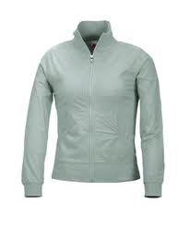](http://www.google.com/imgres?imgurl=http://www.artefirme.com/contents/CasacoFitnessSenhora.jpg&imgrefurl=http://www.artefirme.com/produto.asp?idF=7&idP=33&usg=__QLyh_WZCBc8UYOModJNamrG6jh8=&h=450&w=375&sz=17&hl=en&start=4&zoom=1&tbnid=LeqESz-Cqv893M:&tbnh=127&tbnw=106&ei=sOX1Td3wDImLswao3vigBg&prev=/search?q=casaco&um=1&hl=en&biw=1260&bih=816&tbm=isch&um=1&itbs=1)

**SAPATO**

**CACHARREL**

**BLUSA de…**

**BLUSA**

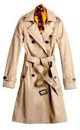[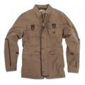](http://www.google.com/imgres?imgurl=http://www.bazarpop.com.br/blog/wp-content/uploads/2008/08/gul_masc5-150x150.jpg&imgrefurl=http://www.bazarpop.com.br/blog/2008/08/28/renner-agora-vende-gul/&usg=__eArZ7yvbS4dK_iVlMly_RQONWHw=&h=150&w=150&sz=7&hl=en&start=0&zoom=1&tbnid=QBgnu776srxq5M:&tbnh=120&tbnw=120&ei=muT1TZreJom1tAa-ovypBg&prev=/search?q=jaqueta+masculina&um=1&hl=en&biw=1260&bih=816&tbm=isch&um=1&itbs=1&iact=rc&dur=187&page=1&ndsp=28&ved=1t:429,r:21,s:0&tx=62&ty=69)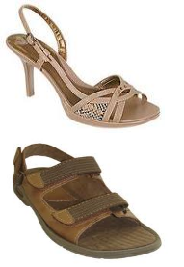[](http://www.google.com/imgres?imgurl=http://www.artefirme.com/contents/CasacoFitnessSenhora.jpg&imgrefurl=http://www.artefirme.com/produto.asp?idF=7&idP=33&usg=__QLyh_WZCBc8UYOModJNamrG6jh8=&h=450&w=375&sz=17&hl=en&start=0&zoom=1&tbnid=LeqESz-Cqv893M:&tbnh=159&tbnw=142&ei=sOX1Td3wDImLswao3vigBg&prev=/search?q=casaco&um=1&hl=en&biw=1260&bih=816&tbm=isch&um=1&itbs=1&iact=rc&dur=109&page=1&ndsp=24&ved=1t:429,r:3,s:0&tx=28&ty=41)

**SANDÁLIA**

**SOBRETUDO**

**CASACO**

**JAQUETA**

[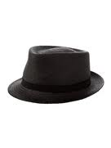](http://www.google.com/imgres?imgurl=http://i2.farfetch.com/10/03/73/97/anthony-peto-chapeu-preto-com-laco-10037397_157484_170.jpg&imgrefurl=http://br.farfetch.com/shopping/women/anthony-peto/hats/items.aspx&usg=__gf68d0N3kyqflJKvAv6CpitnZJ0=&h=227&w=170&sz=6&hl=en&start=23&zoom=1&tbnid=EGdvuUNo4s3feM:&tbnh=159&tbnw=135&ei=cbP4TdSHBI_KtAaWmfyACQ&prev=/search?q=chapeu+preto&um=1&hl=en&sa=X&biw=1260&bih=816&tbm=isch&um=1&itbs=1&iact=rc&dur=47&page=2&ndsp=24&ved=1t:429,r:5,s:23&tx=77&ty=132)[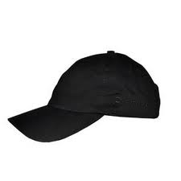](http://www.google.com/imgres?imgurl=http://www.laboutiquecitroen.com.br/media/catalog/product/cache/6/image/5e06319eda06f020e43594a9c230972d/f/i/file_88_32.jpg&imgrefurl=http://www.laboutiquecitroen.com.br/bone-preto-citroen.html&usg=__KFZIqH0gGMnKDYU7nRj1J-5p25s=&h=300&w=300&sz=5&hl=en&start=217&zoom=1&tbnid=Qr1EO7u7fKTAmM:&tbnh=154&tbnw=141&ei=ErP4Tb65GsbbtAbD2dmACQ&prev=/search?q=bon%C3%A9+preto&um=1&hl=en&biw=1260&bih=816&tbm=isch&um=1&itbs=1&iact=rc&dur=109&page=10&ndsp=27&ved=1t:429,r:23,s:217&tx=76&ty=70)[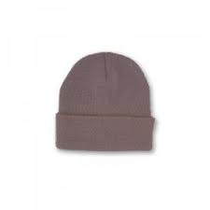](http://www.google.com/imgres?imgurl=http://pt.ruadireita.com/images/product/238/dc62fea559475851c7413d1d6cdc38fc.jpg&imgrefurl=http://pt.ruadireita.com/gorro-com-dobra_14191/&usg=__m9kVuF2VuSpk7yNGeCYuUE265vw=&h=300&w=300&sz=5&hl=en&start=103&zoom=1&tbnid=mvEM3OHVcbkHQM:&tbnh=152&tbnw=224&ei=n7L4TZyjIY7HswbmxaSACQ&prev=/search?q=gorro+cinza+claro&um=1&hl=en&biw=1260&bih=816&tbm=isch&um=1&itbs=1&iact=rc&dur=15&page=5&ndsp=25&ved=1t:429,r:5,s:103&tx=124&ty=76)[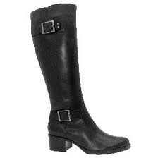](http://www.google.com/imgres?imgurl=http://vmulher3.vila.to/closet-peca/thumb/bota-cano-longo-preta-94-thumb-280.jpg&imgrefurl=http://vilamulher.terra.com.br/comunidade/closet-virtual/pecas/94-bota-cano-longo-preta.html&usg=__FyWCTUvL57AgkDrraEMCXZjPJPM=&h=280&w=280&sz=7&hl=en&start=0&zoom=1&tbnid=1aXad_AzIpvceM:&tbnh=174&tbnw=174&ei=W-r1Tc7kDsrJtAa2_cjpDQ&prev=/search?q=bota+preta&um=1&hl=en&biw=1260&bih=816&tbm=isch&um=1&itbs=1&iact=rc&dur=15&page=1&ndsp=24&ved=1t:429,r:5,s:0&tx=84&ty=43)

**BOTA**

**BONÉ**

**CHAPÉU**

**GORRO**

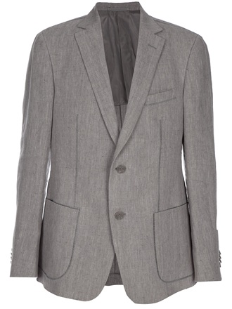[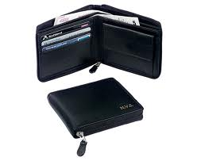](http://www.google.com/imgres?imgurl=http://www.binbin.net/photos/generic/zip/zip-round-gents-wallet-personalised-black.jpg&imgrefurl=http://www.binbin.net/compare/Zip-Round-Gents-Wallet-Personalised-(Black).htm&usg=__yuwcEmpaO187i-mSGKSTl8Yha5o=&h=526&w=644&sz=83&hl=en&start=0&zoom=1&tbnid=EQyf5OM4yu-mPM:&tbnh=147&tbnw=178&ei=vPr1TcP6D8nftAbamImUBg&prev=/search?q=black+wallet&um=1&hl=en&biw=1260&bih=816&tbm=isch&um=1&itbs=1&iact=rc&dur=140&page=1&ndsp=24&ved=1t:429,r:17,s:0&tx=41&ty=100)[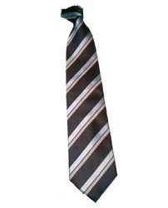](http://www.google.com/imgres?imgurl=http://www.machadinhoestrela.com/noticias/imagens_noticias/gravata.jpg&imgrefurl=http://www.machadinhoestrela.com/colunistas/cidao/opoder_dagravata.html&usg=__wNz8NXxoBVdoXac6MNmm5BKvRBA=&h=495&w=400&sz=15&hl=en&start=0&zoom=1&tbnid=nRPouoFjUY-kRM:&tbnh=164&tbnw=133&ei=pvj1TaLhMMfEsgb1ubyfBg&prev=/search?q=gravata&um=1&hl=en&biw=1260&bih=816&tbm=isch&um=1&itbs=1&iact=rc&dur=0&page=1&ndsp=24&ved=1t:429,r:20,s:0&tx=78&ty=102)[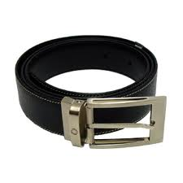](http://www.google.com/imgres?imgurl=http://www.tabacarialee.com.br/Imagens/Produtos/%7b226621B1-121A-4C6C-AEA8-01137E2B4A23%7d_CintoMB_2.jpg&imgrefurl=http://www.tabacarialee.com.br/MaisProduto.asp?Produto=77&usg=__PWeVfKfDhxuQOIUCcQsFENJbi_Y=&h=300&w=300&sz=45&hl=en&start=0&zoom=1&tbnid=r2xRNUNjW6HnmM:&tbnh=167&tbnw=154&ei=tO71TanxD43HsgavnLywBg&prev=/search?q=cinto&um=1&hl=en&biw=1260&bih=816&tbm=isch&um=1&itbs=1&iact=rc&dur=140&page=1&ndsp=21&ved=1t:429,r:5,s:0&tx=96&ty=65)

**BLAZER**

**CINTO**

**CARTEIRA**

**GRAVATA**

[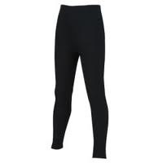](http://www.google.com/imgres?imgurl=http://www.decathlon.pt/products-pictures/250/gd-asset_6009224.jpg&imgrefurl=http://www.decathlon.pt/PT/meias-calcas-8042218/&usg=__cqMpYOKRF3pD6ud7wUPsXV5lNLk=&h=250&w=250&sz=5&hl=en&start=214&zoom=1&tbnid=byKMYJLH21ar0M:&tbnh=159&tbnw=142&ei=Ie_1Tb5JkoSzBuGW4J0P&prev=/search?q=meia+cal%C3%A7a&um=1&hl=en&biw=1260&bih=816&tbm=isch&um=1&itbs=1&iact=rc&dur=31&page=10&ndsp=26&ved=1t:429,r:19,s:214&tx=104&ty=75)[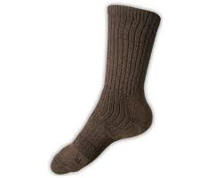](http://www.google.com/imgres?imgurl=http://2.bp.blogspot.com/_MRhB31eXtog/TB1BFebVJQI/AAAAAAAAAU4/_rMcTztrEpk/s1600/meia.jpg&imgrefurl=http://beagaqueeuvejo.blogspot.com/2010/06/pagando-meia.html&usg=__RwL7quDSYusd8pI6bU6-aHIJ56Y=&h=344&w=430&sz=11&hl=en&start=0&zoom=1&tbnid=3ocn8AAmmeBhsM:&tbnh=148&tbnw=185&ei=Fe71Tf-uM8nPtAaytZiOBg&prev=/search?q=meia&um=1&hl=en&biw=1260&bih=816&tbm=isch&um=1&itbs=1&iact=rc&dur=0&page=1&ndsp=23&ved=1t:429,r:1,s:0&tx=134&ty=67)[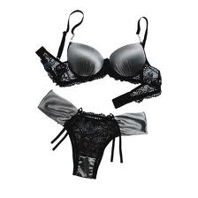](http://www.google.com/imgres?imgurl=http://manequim.abril.com.br/blogs/casamento-dos-sonhos/files/2010/08/lingerie-preta-lua-de-mel-1.jpg&imgrefurl=http://manequim.abril.com.br/blogs/casamento-dos-sonhos/enxoval-2/lingerie-preta-para-usar-na-lua-de-mel/&usg=__NDkF9_z-cI209YynZsv6vwqJhNE=&h=520&w=520&sz=29&hl=en&start=0&zoom=1&tbnid=l-lT6NQ2jWGcVM:&tbnh=161&tbnw=160&ei=5e31Tb_4EJKAswb4yJGjBg&prev=/search?q=lingerie+preta&um=1&hl=en&biw=1260&bih=816&tbm=isch&um=1&itbs=1&iact=rc&dur=0&page=1&ndsp=28&ved=1t:429,r:4,s:0&tx=94&ty=43)[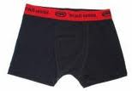](http://www.google.com/imgres?imgurl=http://www.modaativa.com/product_thumb.php?img=images/Cueca_Box_Ecko_MOD0101_.jpg&w=193&h=134&imgrefurl=http://www.modaativa.com/cueca-ecko-mod0101-p-1223.html&usg=__yLAJgITv3N2ntsDoLO00at_4HMs=&h=134&w=193&sz=4&hl=en&start=176&zoom=1&tbnid=nGkWoGEUAk3okM:&tbnh=107&tbnw=154&ei=Hu31TbyQNozZsgapltCOBg&prev=/search?q=cueca+box&um=1&hl=en&biw=1260&bih=816&tbm=isch&um=1&itbs=1&iact=rc&dur=31&page=9&ndsp=24&ved=1t:429,r:18,s:176&tx=90&ty=63)

**MEIA**

**SOUTIEN**

**LINGERIE**

**MEIA CALÇA**

**CALCINHA**

**CUECA**

[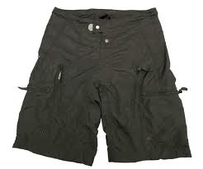](http://www.google.com/imgres?imgurl=http://www.bikemagic.com/news/images/pace06_shorts_hi.jpg&imgrefurl=http://www.bikemagic.com/bike-reviews/pace-riding-shorts/5056.html&usg=__Yqh5MFS8HMUF-8MP7WMleCK1f8A=&h=585&w=700&sz=22&hl=en&start=0&zoom=1&tbnid=m8i1fbLrhj0bYM:&tbnh=148&tbnw=164&ei=qv31Tb3JFoKBswaVmP2ZBg&prev=/search?q=shorts&um=1&hl=en&biw=1260&bih=816&tbm=isch&um=1&itbs=1&iact=rc&dur=172&page=1&ndsp=27&ved=1t:429,r:15,s:0&tx=115&ty=106)[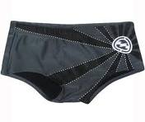](http://www.google.com/imgres?imgurl=http://www.industriasurfskate.com.br/loja/media/catalog/product/cache/1/image/5e06319eda06f020e43594a9c230972d/i/n/industriass-sunga-infantil-billabong-rising-fire-pro-01.jpg&imgrefurl=http://www.industriasurfskate.com.br/loja/infantil/masculino/sunga-infantil-billabong-rising.html&usg=__qveeIggx6x3gNfNmZnT9GUsZjQ0=&h=507&w=601&sz=33&hl=en&start=127&zoom=1&tbnid=R2ACgk4SSadDVM:&tbnh=141&tbnw=167&ei=Tvf1TbvhIYndtAbl-cSPBg&prev=/search?q=sunga&um=1&hl=en&biw=1260&bih=816&tbm=isch&um=1&itbs=1&iact=rc&dur=125&page=6&ndsp=26&ved=1t:429,r:1,s:127&tx=94&ty=47)[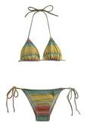](http://www.google.com/imgres?imgurl=http://revistaestilo.abril.com.br/imagem/moda/moda-praia/biquini_surfe_farm.jpg&imgrefurl=http://revistaestilo.abril.com.br/moda/moda-praia/?ctd=2&ft=biquini_surfe_farm.jpg&inc1=moda-praia-biquinis-399650.shtml&usg=__9S6H_cfF67JAgtVNC9SVLl1oVjQ=&h=460&w=311&sz=16&hl=en&start=358&zoom=1&tbnid=cZdNRztmvyW5kM:&tbnh=148&tbnw=104&ei=mfX1TaXANJGBswaRpoSUBg&prev=/search?q=biquini&um=1&hl=en&biw=1260&bih=816&tbm=isch&chk=sbg&um=1&itbs=1&iact=rc&dur=453&page=15&ndsp=25&ved=1t:429,r:5,s:358&tx=50&ty=105)[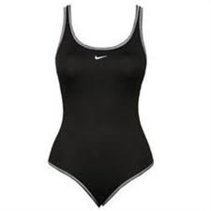](http://www.google.com/imgres?imgurl=http://www.pedala.com.br/Control/ArquivoExibir.aspx?IdArquivo=105808&Tsmp=1811200915000&imgrefurl=http://www.pedala.com.br/Produto/Aquaticos/Natacao/Nike/Maio-Nike.aspx&usg=__MIMsmQvpXk8gHOyXT7nFlfwD2Zc=&h=350&w=350&sz=7&hl=en&start=587&zoom=1&tbnid=9-Fv-PNAuYfT3M:&tbnh=160&tbnw=129&ei=M_f1TZuOKMWh-Qbi25H0Bg&prev=/search?q=mai%C3%B4&start=234&um=1&hl=en&biw=1260&bih=816&output=images_json&tbm=isch&chk=sbg&um=1&itbs=1&iact=rc&dur=16&page=23&ndsp=26&ved=1t:429,r:20,s:587&tx=79&ty=99)

**SUNGA**

**SHORTS**

**BIQUINI**

**MAIÔ**

[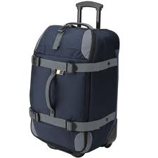](http://www.google.com/imgres?imgurl=http://i.s8.com.br/images/fashion/cover/img6/21565216_4.jpg&imgrefurl=http://www.submarino.com.br/produto/31/21565216/mala+de+viagem+c/+rodas+sport+duffel+azul+tam.+p-+case+logic&usg=__DfHgGWbYCHKR-iGYsuvWfmBM3R0=&h=500&w=500&sz=31&hl=en&start=48&zoom=1&tbnid=wICI4zWKMV9NtM:&tbnh=151&tbnw=151&ei=avj1Tf2-LMjRtAat4omPBg&prev=/search?q=mala+de+rodas&um=1&hl=en&biw=1260&bih=816&tbm=isch&um=1&itbs=1&iact=rc&dur=0&page=3&ndsp=24&ved=1t:429,r:19,s:48&tx=70&ty=69)[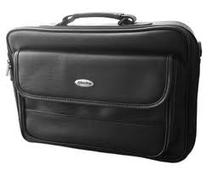](http://www.google.com/imgres?imgurl=http://updistribuidora.com.br/site/produtos/fotos/1/MALETA-NOTE-2-DIV-1120.jpg&imgrefurl=http://updistribuidora.com.br/site/produtos/fotos/1/&usg=__KZvmRoAUnGdoK0Bs85fkge9gMFU=&h=300&w=350&sz=17&hl=en&start=0&zoom=1&tbnid=ENiMCzZJVjb9rM:&tbnh=158&tbnw=181&ei=I_j1Ten9J8rKtAbF0dCnBg&prev=/search?q=maleta&um=1&hl=en&biw=1260&bih=816&tbm=isch&um=1&itbs=1&iact=rc&dur=32&page=1&ndsp=22&ved=1t:429,r:5,s:0&tx=172&ty=103)[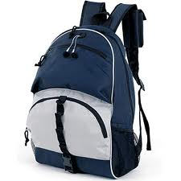](http://www.google.com/imgres?imgurl=http://astuasbalas.com/wp-content/uploads/2008/06/sc414_mochila_web.gif&imgrefurl=http://www.sodahead.com/fun/how-are-you-people-pronouncing-this-word/question-150842/?page=9&usg=__00oCxZCnrR58odbNdf3XrB0udhs=&h=333&w=333&sz=53&hl=en&start=0&zoom=1&tbnid=KEqmT3EBLszQyM:&tbnh=162&tbnw=162&ei=wff1TYW_HMrJtAa2_cjpDQ&prev=/search?q=mochila&um=1&hl=en&biw=1260&bih=816&tbm=isch&um=1&itbs=1&iact=rc&dur=0&page=1&ndsp=25&ved=1t:429,r:1,s:0&tx=122&ty=34)[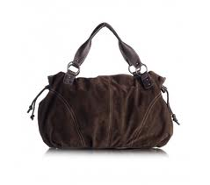](http://www.google.com/imgres?imgurl=http://coisasdemulher.tv/wp-content/uploads/2011/03/bolsa1.png&imgrefurl=http://coisasdemulher.tv/organize-a-sua-bolsa/&usg=__ifxM8eQSFHaqoQtF-XvgWaCEueM=&h=298&w=337&sz=87&hl=en&start=27&zoom=1&tbnid=I34MljgjjJGaWM:&tbnh=157&tbnw=188&ei=gPf1Tf6NN8nbtAbf2uicBg&prev=/search?q=bolsa&um=1&hl=en&biw=1260&bih=816&tbm=isch&um=1&itbs=1&iact=rc&dur=47&page=2&ndsp=27&ved=1t:429,r:17,s:27&tx=104&ty=60)

**MALA**

**BOLSA**

[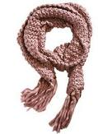](http://www.google.com/imgres?imgurl=http://2.bp.blogspot.com/_eE1uYouV2lY/S_w-A28s1UI/AAAAAAAABqg/lCSRw7k23y0/s1600/242_cachecol_02.jpg&imgrefurl=http://esquadraodamodabh.blogspot.com/2010/05/cachecol-para-embelezar-o-inverno.html&usg=__xPy9-I9tqzI88QpC0OoMuTaaCfs=&h=450&w=329&sz=18&hl=en&start=55&zoom=1&tbnid=0-3EdJxqQxDJ4M:&tbnh=140&tbnw=102&ei=tfP1TeePBIfOswaz7fSwBg&prev=/search?q=cachecol&um=1&hl=en&biw=1260&bih=816&tbm=isch&um=1&itbs=1&iact=rc&dur=109&page=3&ndsp=30&ved=1t:429,r:10,s:55&tx=67&ty=45)[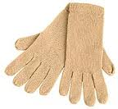](http://www.google.com/imgres?imgurl=http://www.noteaqui.com/wp-content/uploads/2011/05/luvas-l%C3%A3.jpg&imgrefurl=http://annalaurasla.blogspot.com/2011/06/teste-o-que-voce-mais-usa-no-inverno.html&usg=__gYJa19bSHht88emj9kdJDLl_m-c=&h=167&w=180&sz=8&hl=en&start=98&zoom=1&tbnid=xf55c-ICVZYKGM:&tbnh=133&tbnw=144&ei=h_P1TZ_oFcfQsgaggbWaBg&prev=/search?q=luva+de+frio&um=1&hl=en&biw=1260&bih=816&tbm=isch&um=1&itbs=1&iact=rc&dur=0&page=5&ndsp=25&ved=1t:429,r:21,s:98&tx=87&ty=60)[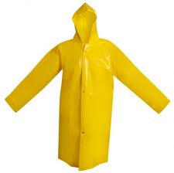](http://www.google.com/imgres?imgurl=http://www.americaseg.com.br/image2.php?img=fotos/03-aug-46-33_dscf7013.jpg&width=440&height=400&imgrefurl=http://www.americaseg.com.br/?op=detalhe&id=16&PHPSESSID=8d77eb5074ebc6910c65e8df0b26b9fa&usg=__A_tQSAm-l6V7XB3G4SKmcwfmNAc=&h=429&w=430&sz=12&hl=en&start=0&zoom=1&tbnid=c7-h4Bi7xNcPMM:&tbnh=164&tbnw=164&ei=VPn1TZPzBseDswbzoNSTBg&prev=/search?q=capa+de+chuva&um=1&hl=en&biw=1260&bih=816&tbm=isch&um=1&itbs=1&iact=rc&dur=203&page=1&ndsp=26&ved=1t:429,r:3,s:0&tx=102&ty=78)[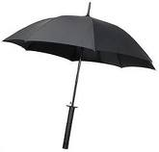](http://www.google.com/imgres?imgurl=http://vaiquevai.com.br/wp-content/uploads/2009/05/espada_guarda_chuva_samurai_aberta.jpg&imgrefurl=http://vaiquevai.com.br/2009/05/guarda-chuva-em-forma-de-espada-de-samurai/&usg=__-Yq7gRd1D_j9hfEI6RuBKeOaJ9w=&h=279&w=291&sz=8&hl=en&start=25&zoom=1&tbnid=YeIJ7raqJzj4nM:&tbnh=151&tbnw=157&ei=N_n1Te6IO43dsgaO2424Bg&prev=/search?q=guarda+chuva&um=1&hl=en&biw=1260&bih=816&tbm=isch&um=1&itbs=1&iact=rc&dur=0&page=2&ndsp=24&ved=1t:429,r:0,s:25&tx=47&ty=79)

**CACHICOL**

**LUVA**

**CAPA**

**GUARDA-CHUVA**

**MALETA**

**MOCHILA**