**FRUTAS**

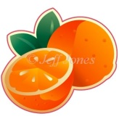    

**UVA**

**ABACAXI**

**BANANA**

**ABACATE**

**LARANJA**

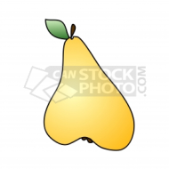    [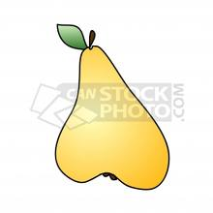](http://www.google.com.br/imgres?imgurl=http://preview.canstockphoto.com/canstock2002972.png&imgrefurl=http://www.canstockphoto.com.br/p%C3%AAra-2002972.html&usg=__his64wh8UU74GwyKaG_KoGyFeXg=&h=275&w=275&sz=40&hl=pt-BR&start=6&zoom=1&tbnid=7tGXRiUlmp_HLM:&tbnh=114&tbnw=114&ei=F4_bTd3pAYfQsgayv5DrDg&prev=/search?q=ilustrac%C3%A3o+de+p%C3%AAra&hl=pt-BR&gbv=2&biw=1260&bih=816&tbm=isch&itbs=1)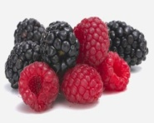

**PÊRA**

**AMORA**

**FRAMBOESA**

**MORANGO**

**MAÇÃ**

**MELÂNCIA**

 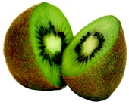  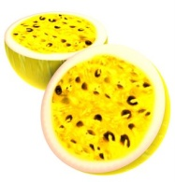 [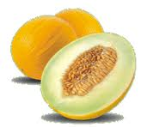](http://www.google.com/imgres?imgurl=http://blig.ig.com.br/mammagorda/files/2009/04/mele3o_grande.gif&imgrefurl=http://blig.ig.com.br/mammagorda/2009/04/02/caipirinha-de-melao/&usg=__CTMNpmf83M5E0R7kHlKZisdhmSA=&h=185&w=205&sz=18&hl=en&start=24&zoom=1&tbnid=cx9XzT4lnfKGBM:&tbnh=148&tbnw=164&ei=NJXbTYyvF8nPtAbsq8TGDg&prev=/search?q=mel%C3%A3o&um=1&hl=en&sa=N&biw=1260&bih=816&tbm=isch&um=1&itbs=1&iact=rc&dur=422&sqi=2&page=2&ndsp=24&ved=1t:429,r:10,s:24&tx=89&ty=83)

**MELÃO**

**MARACUJÁ**

**KIWI**

**LIMÃO**

**PÊSSEGO**

[](http://www.google.com.br/imgres?imgurl=http://preview.canstockphoto.com/canstock0564675.png&imgrefurl=http://www.canstockphoto.com.br/ameixa-0564675.html&usg=__U7-dgW2mz74pJAPg57BELFVswJc=&h=285&w=325&sz=78&hl=pt-BR&start=137&zoom=1&tbnid=qfOJ-x7rIjYd1M:&tbnh=155&tbnw=177&ei=O5HbTe-VLo-SswavqtzvDg&prev=/search?q=ameixa&hl=pt-BR&gbv=2&biw=1260&bih=816&tbm=isch&itbs=1&iact=rc&dur=0&sqi=2&page=7&ndsp=20&ved=1t:429,r:11,s:137&tx=97&ty=98) [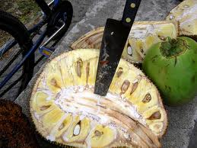](http://www.google.com/imgres?imgurl=http://farm1.static.flickr.com/37/99639854_27a90fb287.jpg&imgrefurl=http://www.flickriver.com/photos/lucypassos/99639854/&usg=__FBZ3WQ62N9aEPxuFUAYKxSk1seE=&h=375&w=500&sz=158&hl=en&start=0&zoom=1&tbnid=BI0_bZkc6dlKJM:&tbnh=161&tbnw=174&ei=oZnbTaDgG4bOswaXlu3kDg&prev=/search?q=jaca&um=1&hl=en&biw=1260&bih=816&tbm=isch&um=1&itbs=1&iact=rc&dur=0&sqi=2&page=1&ndsp=22&ved=1t:429,r:0,s:0&tx=124&ty=113) [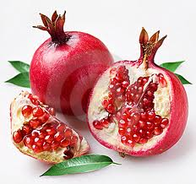](http://www.google.com/imgres?imgurl=http://todaperfeita.com.br/wp-content/uploads/2010/12/rom%C3%A3.jpg&imgrefurl=http://todaperfeita.com.br/simpatia-da-roma-para-o-dia-de-reis-6-de-janeiro/&usg=__zJaWCDBAnRIiB4bhCMcQ5vpXIPc=&h=282&w=300&sz=71&hl=en&start=0&zoom=1&tbnid=TlLe9toR3p6VKM:&tbnh=158&tbnw=191&ei=x5rbTa2BJ5DRsga5_7ndDg&prev=/search?q=rom%C3%A3&um=1&hl=en&biw=1260&bih=816&tbm=isch&um=1&itbs=1&iact=rc&dur=0&sqi=2&page=1&ndsp=20&ved=1t:429,r:3,s:0&tx=107&ty=103) 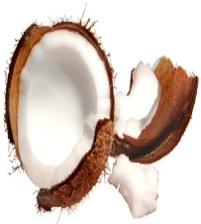 [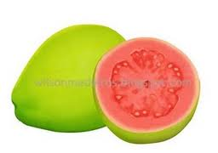](http://www.google.com/imgres?imgurl=http://1.bp.blogspot.com/_xjq9fm_t2nM/RnCWvoUoJSI/AAAAAAAAAEE/mysvvN4qAGU/s320/goiaba-copy.jpg&imgrefurl=http://wilsonmedeiros.blogspot.com/2007_06_01_archive.html&usg=__2D_gB4h4DMeoVarYRZMbWytHO60=&h=226&w=320&sz=10&hl=en&start=0&zoom=1&tbnid=e_t8XtbkL2z_LM:&tbnh=160&tbnw=207&ei=QaHbTaOMEsTSsgaVpLnTDg&prev=/search?q=ilustracao+de+goiaba&um=1&hl=en&biw=1260&bih=816&tbm=isch&um=1&itbs=1&iact=rc&dur=0&sqi=2&page=1&ndsp=24&ved=1t:429,r:14,s:0&tx=107&ty=86)

**GOIABA**

**COCO**

**ROMÃ**

**JACA**

**AMEIXA**

[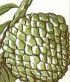](http://www.google.com/imgres?imgurl=http://www.vivabrazil.com/vivabrazil/images/sugar_13.jpg&imgrefurl=http://www.vivabrazil.com/vivabrazil/pinha.htm&usg=__jRuaJuoD1Kdyf_RnFZqlzUY9oTE=&h=139&w=119&sz=5&hl=en&start=88&zoom=1&tbnid=tEnOisxrWCDviM:&tbnh=111&tbnw=95&ei=6ZnbTfnxBs31sgaVtO3kDg&prev=/search?q=pinha&um=1&hl=en&biw=1260&bih=816&tbm=isch&um=1&itbs=1&iact=rc&dur=266&sqi=2&page=5&ndsp=23&ved=1t:429,r:13,s:88&tx=50&ty=56) [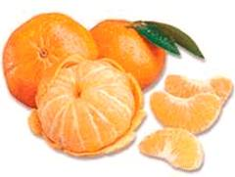](http://www.google.com/imgres?imgurl=http://www.guiavegano.com.br/vegan/images/stories/produtos/tangerina1.jpg&imgrefurl=http://dialogospoliticos.wordpress.com/2010/03/25/outono-conheca-os-beneficios-das-frutas-desta-estacao/&usg=__yJkfxCmYggnoAFHu_z09oRegvw0=&h=227&w=301&sz=31&hl=en&start=0&zoom=1&tbnid=M6U2m_buVNOmAM:&tbnh=152&tbnw=202&ei=P5nbTaS9IMTJtAbtkNjdDg&prev=/search?q=mixirica&um=1&hl=en&sa=N&biw=1260&bih=816&tbm=isch&um=1&itbs=1&iact=rc&dur=156&sqi=2&page=1&ndsp=20&ved=1t:429,r:5,s:0&tx=105&ty=102) [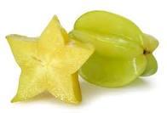](http://www.google.com/imgres?imgurl=http://www.apriliani.com/wp-content/uploads/2010/05/carambola.jpg&imgrefurl=http://www.apriliani.com/carambola&usg=__84eQg9TtCbpRHZTiHY8_N6KDYYY=&h=335&w=493&sz=23&hl=en&start=0&zoom=1&tbnid=ulL0zn_tav1ajM:&tbnh=124&tbnw=182&ei=d5nbTdmXBdSBswbNh-HKDg&prev=/search?q=carambola&um=1&hl=en&biw=1260&bih=816&tbm=isch&um=1&itbs=1&iact=rc&dur=359&sqi=2&page=1&ndsp=24&ved=1t:429,r:12,s:0&tx=93&ty=74) [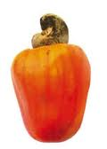](http://www.google.com/imgres?imgurl=http://www.paty.posto7.com.br/frutacaju150x211.jpg&imgrefurl=http://www.paty.posto7.com.br/frutacaju.htm&usg=__Obe5dyr2gb7Y0ztUlMupMZgUW-o=&h=211&w=150&sz=5&hl=en&start=0&zoom=1&tbnid=8kkPLTJtU62dpM:&tbnh=168&tbnw=96&ei=c5rbTYWQE8zSsgbszcDpDg&prev=/search?q=caj%C3%BA&um=1&hl=en&biw=1260&bih=816&tbm=isch&um=1&itbs=1&iact=rc&dur=16&sqi=2&page=1&ndsp=21&ved=1t:429,r:8,s:0&tx=52&ty=105) [](http://www.google.com.br/imgres?imgurl=http://ladydyke.com/wp-content/uploads/2009/05/desenho-de-cereja-pra-tatuar.jpg&imgrefurl=http://ladydyke.com/page/3&usg=__px4LS3v78o3aZ4CgF28K8SxH1d4=&h=364&w=338&sz=12&hl=pt-BR&start=0&zoom=1&tbnid=bx0OOaXe3HwZhM:&tbnh=151&tbnw=140&ei=cZHbTa_DOIrCtAaJxdTLDg&prev=/search?q=cereja&hl=pt-BR&gbv=2&biw=1260&bih=816&tbm=isch&itbs=1&iact=rc&dur=0&sqi=2&page=1&ndsp=24&ved=1t:429,r:2,s:0&tx=102&ty=104)

**CEREJA**

**CAJÚ**

**CARAMBOLA**

**MIXIRICA**

**PINHA**

**FRUTA DO CONDE**

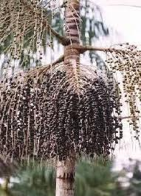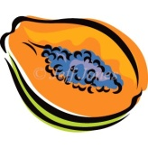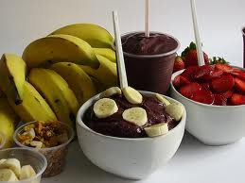 [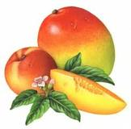](http://www.google.com/imgres?imgurl=http://fineartamerica.com/images-medium/suave-mango-peach-a3451.jpg&imgrefurl=http://fineartamerica.com/featured/suave-mango-peach-a3451.html&usg=__W_SgoiyCdsutoIW_7tDvYdEX76Q=&h=300&w=304&sz=65&hl=en&start=0&zoom=1&tbnid=c1pOC0sWL2ZYIM:&tbnh=145&tbnw=144&ei=l5_bTcXvHM7KtAajsYXlDg&prev=/search?q=mango&um=1&hl=en&biw=1260&bih=816&tbm=isch&um=1&itbs=1&iact=rc&dur=0&sqi=2&page=1&ndsp=24&ved=1t:429,r:17,s:0&tx=63&ty=45) [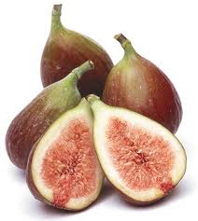](http://www.google.com/imgres?imgurl=http://1.bp.blogspot.com/_3grf5TZHi2M/TTbxn99shZI/AAAAAAAAAB4/hLeMtEVbOqU/s1600/produto_figo.jpg&imgrefurl=http://saude-natural.blogspot.com/2011/01/frutas-para-perder-barriga.html&usg=__KlIzN7roz79Uf1lGATgqueUanRU=&h=391&w=350&sz=25&hl=en&start=0&zoom=1&tbnid=f1c6ATmjuDrFzM:&tbnh=161&tbnw=142&ei=uqDbTa3sHI6EswbRvJXgDg&prev=/search?q=figo+fruto&um=1&hl=en&sa=X&biw=1260&bih=816&tbm=isch&um=1&itbs=1&iact=rc&dur=110&sqi=2&page=1&ndsp=24&ved=1t:429,r:1,s:0&tx=48&ty=96) [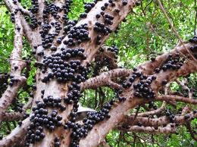](http://www.google.com/imgres?imgurl=http://1.bp.blogspot.com/_dthE9LbmjhE/TO2bB1qMOWI/AAAAAAAACEQ/cE-oSSKpAu4/s1600/uba_jabuticaba.jpg&imgrefurl=http://gardeningandthespanishway-rohrerbot.blogspot.com/2010/11/jabuticaba.html&usg=__ipiCv1i2061VA-FG1Xq3JyCvllI=&h=337&w=450&sz=85&hl=en&start=0&zoom=1&tbnid=E5gwfk86V8A6HM:&tbnh=171&tbnw=245&ei=r5_bTeuoLMm1tAav0fXkDg&prev=/search?q=jabuticaba&um=1&hl=en&biw=1260&bih=816&tbm=isch&um=1&itbs=1&iact=rc&dur=0&sqi=2&page=1&ndsp=24&ved=1t:429,r:3,s:0&tx=140&ty=90) [](http://www.google.com/imgres?imgurl=http://farm1.static.flickr.com/37/99639854_27a90fb287.jpg&imgrefurl=http://www.flickriver.com/photos/lucypassos/99639854/&usg=__FBZ3WQ62N9aEPxuFUAYKxSk1seE=&h=375&w=500&sz=158&hl=en&start=1&zoom=1&tbnid=BI0_bZkc6dlKJM:&tbnh=98&tbnw=130&ei=oZnbTaDgG4bOswaXlu3kDg&prev=/search?q=jaca&um=1&hl=en&biw=1260&bih=816&tbm=isch&um=1&itbs=1)[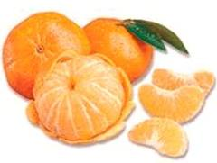](http://www.google.com/imgres?imgurl=http://4.bp.blogspot.com/_aNfrD0oUJtM/SGfwKTe1ZlI/AAAAAAAAAd8/VnTajfCAStc/s400/tangerina1.jpg&imgrefurl=http://memoriasdeumaloira.blogspot.com/2008/06/hora-da-vitamina.html&usg=__UuyEJttx2SvKciJ3oBwLdRBMhPU=&h=227&w=301&sz=12&hl=en&start=2&zoom=1&tbnid=XKQJ3q25KXjQuM:&tbnh=87&tbnw=116&ei=P5nbTaS9IMTJtAbtkNjdDg&prev=/search?q=mixirica&um=1&hl=en&sa=N&biw=1260&bih=816&tbm=isch&um=1&itbs=1)[](http://www.google.com/imgres?imgurl=http://www.guiavegano.com.br/vegan/images/stories/produtos/tangerina1.jpg&imgrefurl=http://dialogospoliticos.wordpress.com/2010/03/25/outono-conheca-os-beneficios-das-frutas-desta-estacao/&usg=__yJkfxCmYggnoAFHu_z09oRegvw0=&h=227&w=301&sz=31&hl=en&start=6&zoom=1&tbnid=M6U2m_buVNOmAM:&tbnh=87&tbnw=116&ei=P5nbTaS9IMTJtAbtkNjdDg&prev=/search?q=mixirica&um=1&hl=en&sa=N&biw=1260&bih=816&tbm=isch&um=1&itbs=1)[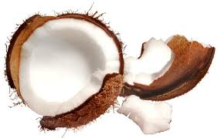](http://www.google.com/imgres?imgurl=http://2.bp.blogspot.com/_V9up7JCcDUQ/TUf42_xASBI/AAAAAAAAAB0/pt6MfiUAJyM/s1600/cPjDDRuReeZjuGisPM5A%5B1%5D.jpg&imgrefurl=http://doencashumanidade.blogspot.com/2011/02/coco.html&usg=__7MtyAObQ9zcORmRBBKcxmd-hSeY=&h=318&w=500&sz=34&hl=en&start=2&zoom=1&tbnid=r9alk9yP_U4qhM:&tbnh=83&tbnw=130&ei=5ZjbTYbHLMfEtAb8pMTmDg&prev=/search?q=c%C3%B4co&um=1&hl=en&biw=1260&bih=816&tbm=isch&um=1&itbs=1)[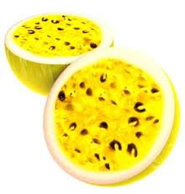](http://www.google.com/imgres?imgurl=http://4.bp.blogspot.com/_NScOGjvwzrU/TGIKxk79wFI/AAAAAAAAAp4/SmxKS076gtE/s1600/maracuja.jpg&imgrefurl=http://kiltxadrez.blogspot.com/2010/08/praga-do-maracuja.html&usg=__1ktfBxc-g8vaucPVLmigh9gqatw=&h=320&w=306&sz=17&hl=en&start=4&zoom=1&tbnid=A2f4Jutt5zH2HM:&tbnh=118&tbnw=113&ei=xZfbTZWCD4O0tAad7M3GDg&prev=/search?q=maracuj%C3%A1&um=1&hl=en&biw=1260&bih=816&tbm=isch&um=1&itbs=1)[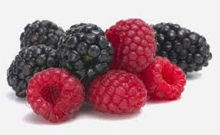](http://www.google.com/imgres?imgurl=http://bp1.blogger.com/_LcozRSVp3Do/SJRiT96MDjI/AAAAAAAAANc/WbEuWFI8KAI/s400/framboesa.jpg&imgrefurl=http://nomatterwhat4us.blogspot.com/2008/08/vinagrete-de-frambroesa.html&usg=__pk4we_P8uXMF7w19_JsHSc1hcHk=&h=244&w=398&sz=18&hl=en&start=10&zoom=1&tbnid=uD7k6Zt9rLJqGM:&tbnh=76&tbnw=124&ei=A5bbTYn-OMPvsga2t5HYDg&prev=/search?q=framboesa&um=1&hl=en&biw=1260&bih=816&tbm=isch&um=1&itbs=1)[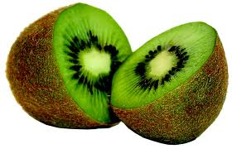](http://www.google.com.br/imgres?imgurl=http://www.prdagente.pr.gov.br/arquivos/Image/c2_festasgastronomicas/fest_kiwi1.a.jpg&imgrefurl=http://dialogospoliticos.wordpress.com/2010/01/16/kiwi-contem-tres-vezes-mais-vitamina-c-que-a-laranja/&usg=__3xb1pxUbMsY7pxRIiDFa_ws9IgY=&h=669&w=1038&sz=375&hl=pt-BR&start=8&zoom=1&tbnid=1XEaO_a3RvR-CM:&tbnh=97&tbnw=150&ei=EJHbTaq9CoXctAacjL3ZDg&prev=/search?q=kiwi&hl=pt-BR&sa=X&gbv=2&biw=1260&bih=816&tbm=isch&itbs=1)

**JABUTICABA**

**FIGO**

**MANGA**

**AÇAÍ**

**MAMÃO**