Introduction to Quantitative Research

Thu 3 & 10 Nov 2016

Pertti Jokivuori, Ph.D Lecturer

In the social sciences, quantitative research refers to the systematic empirical investigation of social phenomena via statistical techniques.
The process of measurement is central to quantitative research
it provides the fundamental connection between empirical observation and statistical expression of quantitative relationships.

Quantitative research is generally made using scientific methods, which can include:
- The generation of models, theories and hypotheses
- The development of instruments and methods for measurement
- Collection of empirical data
- Experimental control and manipulation of variables
- Modeling and analysis of data
- Evaluation of results

What is Quantitative Research?
The word "quantitative" expresses data that is subject to measurements and numbers. Quantitative methods of research in sociology employ data that is objective and statistical. This type of research generates information with trends and correlations.
Quantitative information is similar to scientific-style data; where objects are analyzed in exact descriptions, often utilizing logic and reasoning.

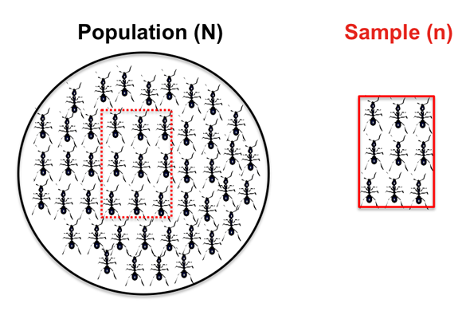

Significant Differences between Qualitative and Quantitative
- When employing quantitative research methods, the researcher usually already knows what is expected from the results. On the other hand, researchers that rely on qualitative techniques cannot expect results similar to their hypothesis.
- Qualitative information is subjective and open to interpretation. Quantitative information is more objective; expressed in exact descriptions such as statistics, percentages and numbers.
- Qualitative research methods portray what the social world has in store for people of various backgrounds and living situations. This type of research communicates results through detailed observation and description.
- Conversely; quantitative research is a reflection of people and situations from a specific point of view, such as the rate of divorce amongst parents of suicidal teenagers, organisational commitment amongst female and male employees.

Quantitative research consists of those studies in which the data concerned can be analysed in terms of numbers ... Research can also be qualitative, that is, it can describe events, persons and so forth scientifically without the use of numerical data ...
Quantitative research is based more directly on its original plans and its results are more readily analysed and interpreted. Qualitative research is more open and responsive to its subject. Both types of research are valid and useful. They are not mutually exclusive. It is possible for a single investigation to use both methods. (Best and Khan, 1989: 89-90) MIXED METHOD

Summa summarum:
Quantitative research is empirical research where the data are in the form of numbers.
Qualitative research is empirical research where the data are not in the form of numbers. (Punch, 1998: 4)

STRENGTHS of Quantitative research:
· Precision and transparency - through quantitative and reliable measurement
· Control - through sampling and design
· Ability to produce causality statements, through the use of controlled experiments
· Statistical techniques allow for sophisticated analyses
· Replicable

Quantitative research is qualitatative!!!

Social scientist is not interested in numbers or coefficients in itself (%-distributions, alfa, eta and beta values or correlation coeffficients), but he/she is interested in social phenomena (connections between variables refer/represent connections between social phenomena)

Social reality is a research subject that a researcher is interested in!

Key elements of Quantitative research:

- Observational units (human being (survey), country, organisation, voluntary association…)
- Variables (quality)
- Values (all qualities have numeric symbols)

♦ Quantitative research means that all variables (qualities) have been expressed in numerical way.

Observational matrix:

SPSS = Statistical Package for the Social Sciences
Analyse descriptive statistics: frequencies, crosstabs, compare means, anova, general linear model, correlate, regression, classify (discriminant), data reduction (factor), scale (reliability analysis).

Transformations recode ja Transform > compute

Data split file and select cases

Graphs bar, line, pie, scatter, boxplot

Three Levels of Quantitative Analysis:

•Descriptive level of analysis (frequencies, graphs)
• The association (or independence/dependence) between variables (variables-oriented study)
• Explanatory analysis (elaboration, multivariate models)

1. Analysing a single variable: Tables, distributions and graphs
2. Analysing two variables: Cross tabulations
3. Analysing two variables: Compare means, One-way ANOVA and linear relationships between variables (correlation)

1. Analysing a single variable: Tables, distributions and graphs

Examples of descriptive analysis:

Have Finns boycotted certain products during last 12 months?

Boycotted certain products last 12 months
 |  | Frequency | Percent | Valid Percent | Cumulative Percent
Valid | Yes | 766 | 34,9 | 34,9 | 34,9
 | No | 1426 | 64,9 | 65,1 | 100,0
 | Total | 2192 | 99,8 | 100,0
Missing | Don't know | 5 | ,2
Total |  | 2197 | 100,0

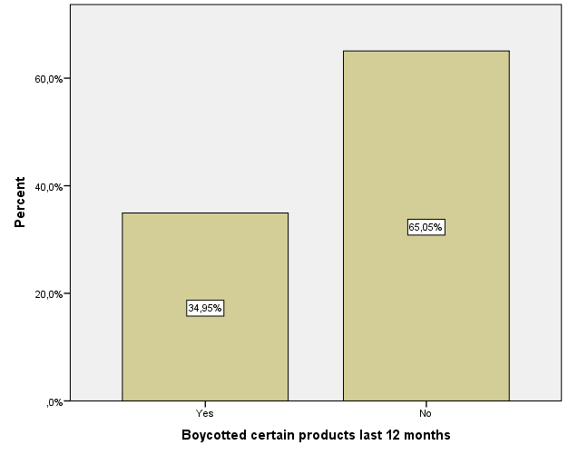

Graphs bar (B17)

Are Finns depressed?

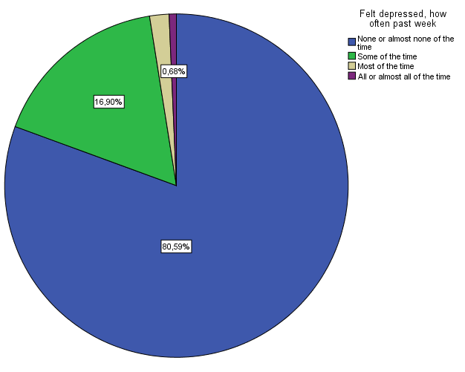

Finns’ confidence towards social institutions:

Descriptive Statistics
 | N | Minimum | Maximum | Mean | Std. Deviation
Trust in country's parliament | 2188 | 0 | 10 | 5,91 | 2,090
Trust in the legal system | 2185 | 0 | 10 | 7,04 | 1,983
Trust in the police | 2195 | 0 | 10 | 8,10 | 1,590
Trust in politicians | 2189 | 0 | 10 | 4,83 | 2,032
Trust in political parties | 2176 | 0 | 10 | 4,89 | 2,002
Trust in the European Parliament | 2127 | 0 | 10 | 5,04 | 2,164
Trust in the United Nations | 2124 | 0 | 10 | 6,55 | 1,935
Valid N (listwise) | 2089

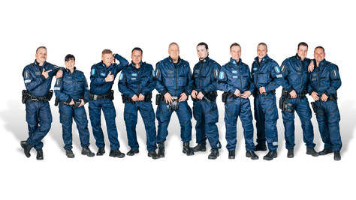
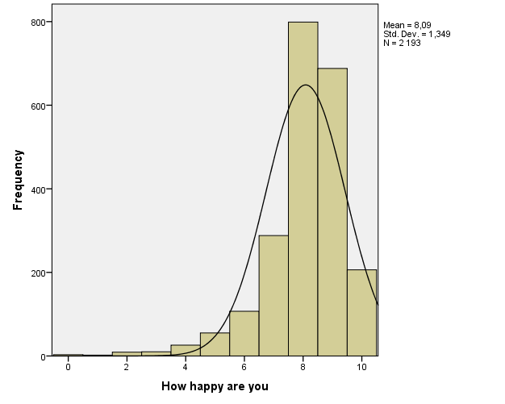

Distribution of a statement concerning organisational commitment:

Belonging to this organisation has a great deal  of personal meaning for me | Totally agree | Partially agree | Not agree, not disagree or can’t say | Partially  disagree | Totally  Disagree
 | 25% | 38% | 22% | 11% | 4%

ESS Statement, B27: Gay men and lesbians should be free to live their own life as they wish

Gays and lesbians free to live life as they wish
 |  | Frequency | Percent | Valid Percent | Cumulative Percent
Valid | Agree strongly | 884 | 40,2 | 40,5 | 40,5
 | Agree | 748 | 34,0 | 34,3 | 74,8
 | Neither agree nor disagree | 326 | 14,8 | 14,9 | 89,7
 | Disagree | 148 | 6,7 | 6,8 | 96,5
 | Disagree strongly | 77 | 3,5 | 3,5 | 100,0
 | Total | 2183 | 99,4 | 100,0
Missing | Refusal | 4 | ,2
 | Don't know | 10 | ,5
 | Total | 14 | ,6
Total |  | 2197 | 100,0

2. Analysing two variables: Cross tabulations

First:

Feeling of safety of walking alone in local area after dark
 |  | Frequency | Percent | Valid Percent | Cumulative Percent
Valid | Very safe | 861 | 39,2 | 39,3 | 39,3
 | Safe | 1154 | 52,5 | 52,7 | 92,0
 | Unsafe | 161 | 7,3 | 7,3 | 99,3
 | Very unsafe | 15 | ,7 | ,7 | 100,0
 | Total | 2191 | 99,7 | 100,0
Missing | Don't know | 6 | ,3
Total |  | 2197 | 100,0

Has that safety/unsafety -feeling something to do with a gender?

Feeling of safety of walking alone in local area after dark * Gender Crosstabulation
 |  |  | Gender |  | Total
 |  |  | Male | Female
Feeling of safety of walking alone in local area after dark | Very safe | Count | 570 | 291 | 861
 |  | Expected Count | 421,7 | 439,3 | 861,0
 |  | % within Feeling of safety of walking alone in local area after dark | 66,2% | 33,8% | 100,0%
 |  | % within Gender | 53,1% | 26,0% | 39,3%
 | Safe | Count | 478 | 676 | 1154
 |  | Expected Count | 565,1 | 588,9 | 1154,0
 |  | % within Feeling of safety of walking alone in local area after dark | 41,4% | 58,6% | 100,0%
 |  | % within Gender | 44,5% | 60,5% | 52,7%
 | Unsafe | Count | 24 | 137 | 161
 |  | Expected Count | 78,8 | 82,2 | 161,0
 |  | % within Feeling of safety of walking alone in local area after dark | 14,9% | 85,1% | 100,0%
 |  | % within Gender | 2,2% | 12,3% | 7,3%
 | Very unsafe | Count | 1 | 14 | 15
 |  | Expected Count | 7,3 | 7,7 | 15,0
 |  | % within Feeling of safety of walking alone in local area after dark | 6,7% | 93,3% | 100,0%
 |  | % within Gender | 0,1% | 1,3% | 0,7%
Total |  | Count | 1073 | 1118 | 2191
 |  | Expected Count | 1073,0 | 1118,0 | 2191,0
 |  | % within Feeling of safety of walking alone in local area after dark | 49,0% | 51,0% | 100,0%
 |  | % within Gender | 100,0% | 100,0% | 100,0%

Chi-Square Tests
 | Value | df | Asymp. Sig. (2-sided)
Pearson Chi-Square | 214,123ª | 3 | ,000
Likelihood Ratio | 226,326 | 3 | ,000
Linear-by-Linear Association | 212,527 | 1 | ,000
N of Valid Cases | 2191
a. 0 cells (0,0%) have expected count less than 5. The minimum expected count is 7,35.

Statistical tests are used in quantitative analyses to show that is it possible to generalize results in data (differences between groups, connections between variables) to cover the whole population too.
Chi-square (independence-test): association between proportions

Significance levels:
p< .05 statistically almost significant (950/1000) 5 % likelihood that a result is accurate just in sample (95% likelihood to make a statitical generalisation)
p< .01 statistically significant (990/1000) 1% likelihood that a result is accurate just in sample (99% likelihood to make a statitical generalisation)
p< .001 statistically highly significant (999/1000) 0.1 % likelihood that a result is accurate just in sample (99.9% likelihood to make a statitical generalisation)

Analysing two variables: Compare means (One-way Anova = analysis of variances) and linear relationships between variables (correlation)

How happy are you
 |  | Frequency | Percent | Valid Percent | Cumulative Percent
Valid | Extremely unhappy | 3 | ,1 | ,1 | ,1
 | 1 | 2 | ,1 | ,1 | ,2
 | 2 | 9 | ,4 | ,4 | ,6
 | 3 | 10 | ,5 | ,5 | 1,1
 | 4 | 26 | 1,2 | 1,2 | 2,3
 | 5 | 55 | 2,5 | 2,5 | 4,8
 | 6 | 107 | 4,9 | 4,9 | 9,7
 | 7 | 288 | 13,1 | 13,1 | 22,8
 | 8 | 799 | 36,4 | 36,4 | 59,2
 | 9 | 688 | 31,3 | 31,4 | 90,6
 | Extremely happy | 206 | 9,4 | 9,4 | 100,0
 | Total | 2193 | 99,8 | 100,0
Missing | Don't know | 4 | ,2
Total |  | 2197 | 100,0

OR:
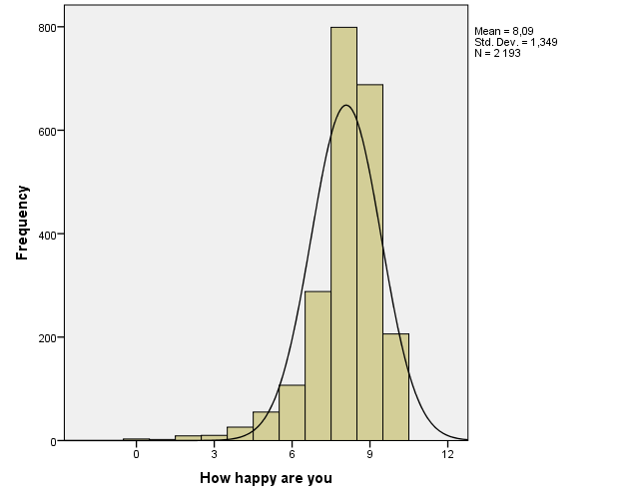

Present income and happiness:

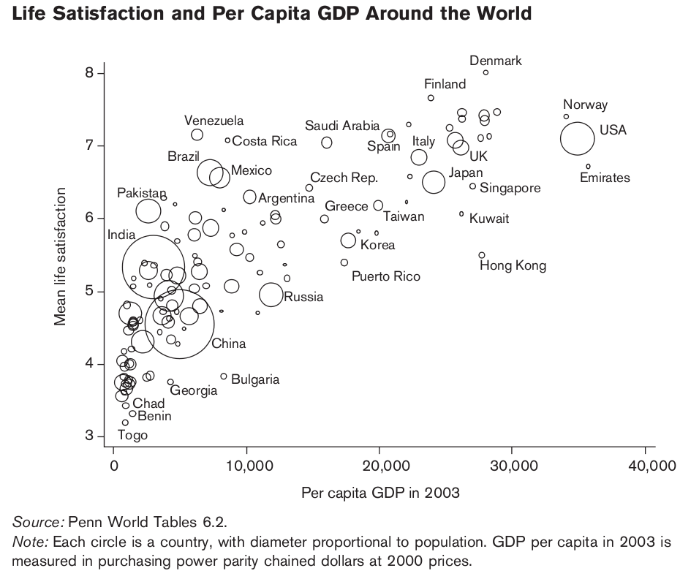

One-way Anova:

Descriptives
How happy are you
 | N | Mean | Std. Deviation | Std. Error | 95% Confidence Interval for Mean |  | Minimum | Maximum
 |  |  |  |  | Lower Bound | Upper Bound
Living comfortably on present income | 514 | 8,47 | 1,076 | ,047 | 8,38 | 8,56 | 3 | 10
Coping on present income | 1380 | 8,12 | 1,244 | ,033 | 8,05 | 8,19 | 0 | 10
Difficult on present income | 221 | 7,39 | 1,579 | ,106 | 7,18 | 7,60 | 2 | 10
Very difficult on present income | 63 | 6,65 | 2,343 | ,295 | 6,06 | 7,24 | 0 | 10
Total | 2178 | 8,09 | 1,344 | ,029 | 8,03 | 8,14 | 0 | 10

Test of Homogeneity of Variances
How happy are you
Levene Statistic | df1 | df2 | Sig.
30,707 | 3 | 2174 | ,000

ANOVA
How happy are you
 | Sum of Squares | df | Mean Square | F | Sig.
Between Groups | 313,370 | 3 | 104,457 | 62,759 | ,000
Within Groups | 3618,403 | 2174 | 1,664
Total | 3931,772 | 2177

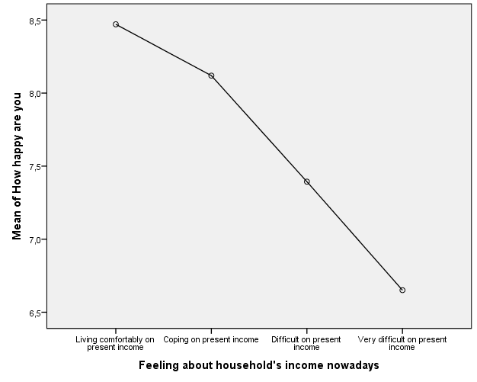

Correlation:

Correlation means linear relationship between two variables. Variables should be so-called continual variables (min --------------------- max)

- Is there a positive, negative or zero correlation between religiousness and happiness?

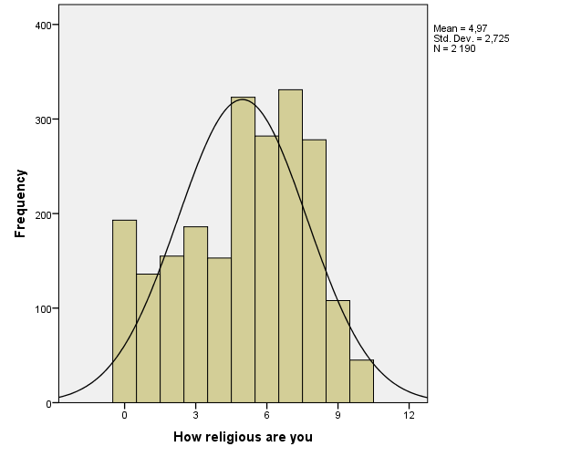

Correlations
 |  | How happy are you | How religious are you
How happy are you | Pearson Correlation | 1 | ,105**
 | Sig. (2-tailed) |  | ,000
 | N | 2193 | 2187
How religious are you | Pearson Correlation | ,105** | 1
 | Sig. (2-tailed) | ,000
 | N | 2187 | 2190
**. Correlation is significant at the 0.01 level (2-tailed).

Correlation matrix:

Correlations
 |  | Most people can be trusted or you can't be too careful | Placement on left right scale | Immigrants make country worse or better place to live | How happy are you | How religious are you | Feel appreciated by people you are close to | Deal with important problems in life | Household's total net income, all sources
Most people can be trusted or you can't be too careful | Pearson Correlation | 1 | ,071** | ,257** | ,273** | ,096** | ,292** | ,209** | ,118**
 | Sig. (2-tailed) |  | ,001 | ,000 | ,000 | ,000 | ,000 | ,000 | ,000
 | N | 2196 | 2096 | 2172 | 2192 | 2190 | 2181 | 2179 | 2061
Placement on left right scale | Pearson Correlation | ,071** | 1 | ,004 | ,118** | ,206** | ,061** | ,091** | ,132**
 | Sig. (2-tailed) | ,001 |  | ,861 | ,000 | ,000 | ,006 | ,000 | ,000
 | N | 2096 | 2096 | 2076 | 2092 | 2091 | 2084 | 2082 | 1983
Immigrants make country worse or better place to live | Pearson Correlation | ,257** | ,004 | 1 | ,149** | ,036 | ,189** | ,137** | ,092**
 | Sig. (2-tailed) | ,000 | ,861 |  | ,000 | ,091 | ,000 | ,000 | ,000
 | N | 2172 | 2076 | 2173 | 2170 | 2168 | 2162 | 2163 | 2046
How happy are you | Pearson Correlation | ,273** | ,118** | ,149** | 1 | ,105** | ,463** | ,408** | ,257**
 | Sig. (2-tailed) | ,000 | ,000 | ,000 |  | ,000 | ,000 | ,000 | ,000
 | N | 2192 | 2092 | 2170 | 2193 | 2187 | 2179 | 2177 | 2059
How religious are you | Pearson Correlation | ,096** | ,206** | ,036 | ,105** | 1 | ,114** | ,053* | -,045*
 | Sig. (2-tailed) | ,000 | ,000 | ,091 | ,000 |  | ,000 | ,013 | ,039
 | N | 2190 | 2091 | 2168 | 2187 | 2190 | 2176 | 2175 | 2058
Feel appreciated by people you are close to | Pearson Correlation | ,292** | ,061** | ,189** | ,463** | ,114** | 1 | ,336** | ,193**
 | Sig. (2-tailed) | ,000 | ,006 | ,000 | ,000 | ,000 |  | ,000 | ,000
 | N | 2181 | 2084 | 2162 | 2179 | 2176 | 2182 | 2172 | 2050
Deal with important problems in life | Pearson Correlation | ,209** | ,091** | ,137** | ,408** | ,053* | ,336** | 1 | ,157**
 | Sig. (2-tailed) | ,000 | ,000 | ,000 | ,000 | ,013 | ,000 |  | ,000
 | N | 2179 | 2082 | 2163 | 2177 | 2175 | 2172 | 2180 | 2053
Household's total net income, all sources | Pearson Correlation | ,118** | ,132** | ,092** | ,257** | -,045* | ,193** | ,157** | 1
 | Sig. (2-tailed) | ,000 | ,000 | ,000 | ,000 | ,039 | ,000 | ,000
 | N | 2061 | 1983 | 2046 | 2059 | 2058 | 2050 | 2053 | 2061
**. Correlation is significant at the 0.01 level (2-tailed).
*. Correlation is significant at the 0.05 level (2-tailed).

Most people can be trusted or you can't be too careful Can’n be too careful 0 ------------- 10 Most people can be trusted
Placement on left right scale Left 0 ------------- 10 Rught
Immigrants make country worse or better place to live Worse placeto live 0 ------------- 10 Better place to live
How happy are you Extremely unhappy 0 ------------- 10 Extremenly happy
How religious are you Not at all religious 0 ------------- 10 Very religious
Feel appreciated by people you are close to Not at all 0 ------------- 10 Completely
Deal with important problems in life Extremely difficult 0 -------------- 10 Extremely easy
Household's total net income/month, all sources Less than €1000 0 -------------- 10 More than €5361

Let’s make some interpretations!

